Question 1a

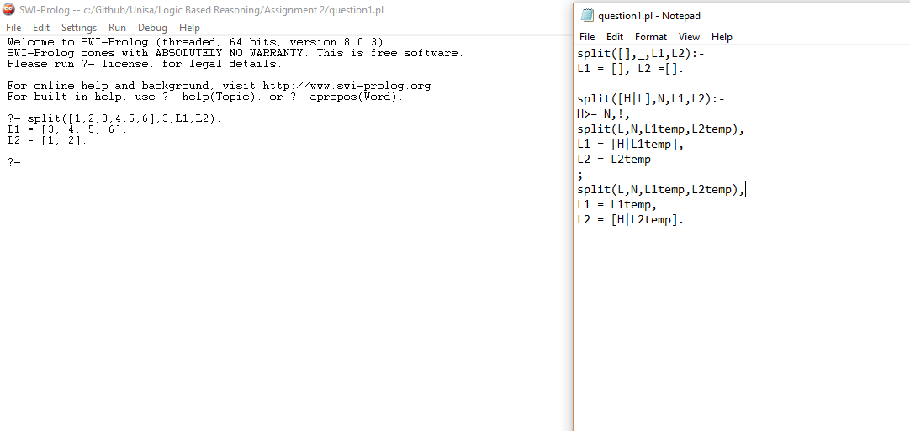

Question 1b

Green cuts are cuts that do not affect the declarative meaning of the program. The order of the statements can be changed and it will not affect the meaning of the program. Red cuts, are cuts that do affect the declarative meaning of the program and reordering the statements will change the meaning of the program.

Question 2a

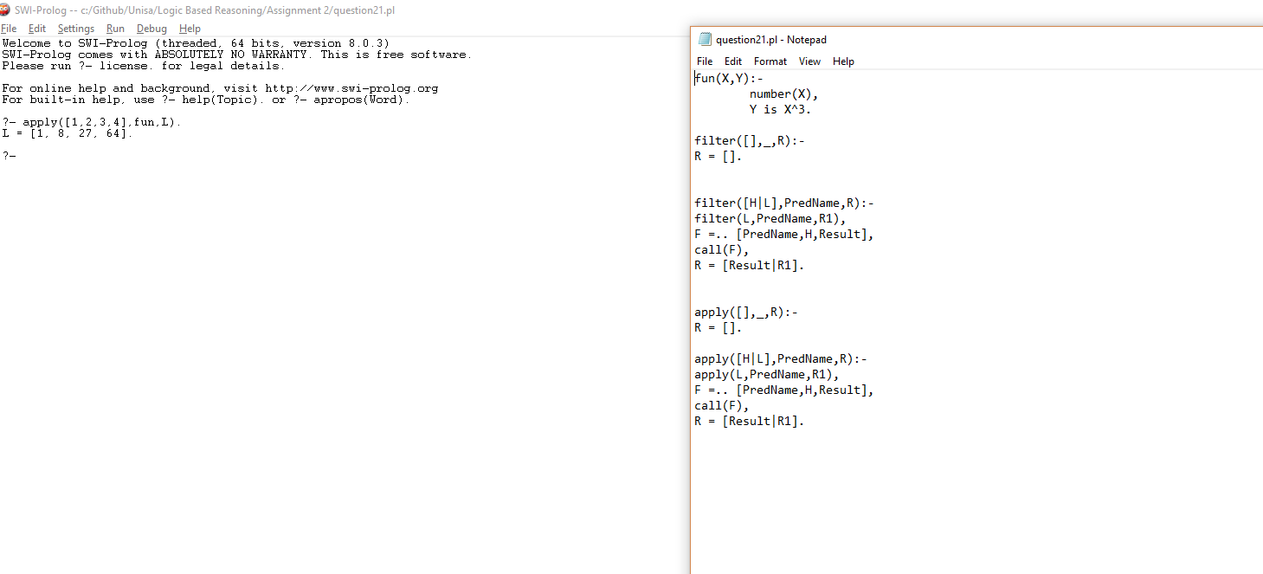

Question 2b

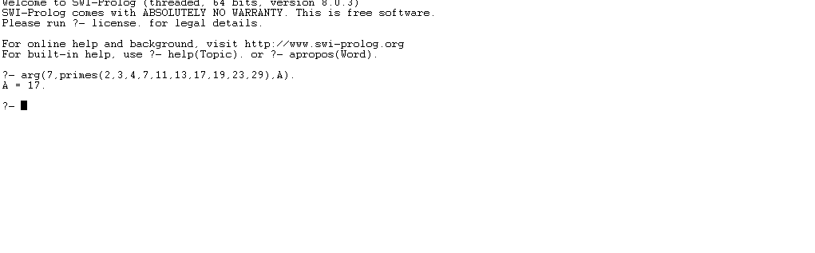

Question 3.1

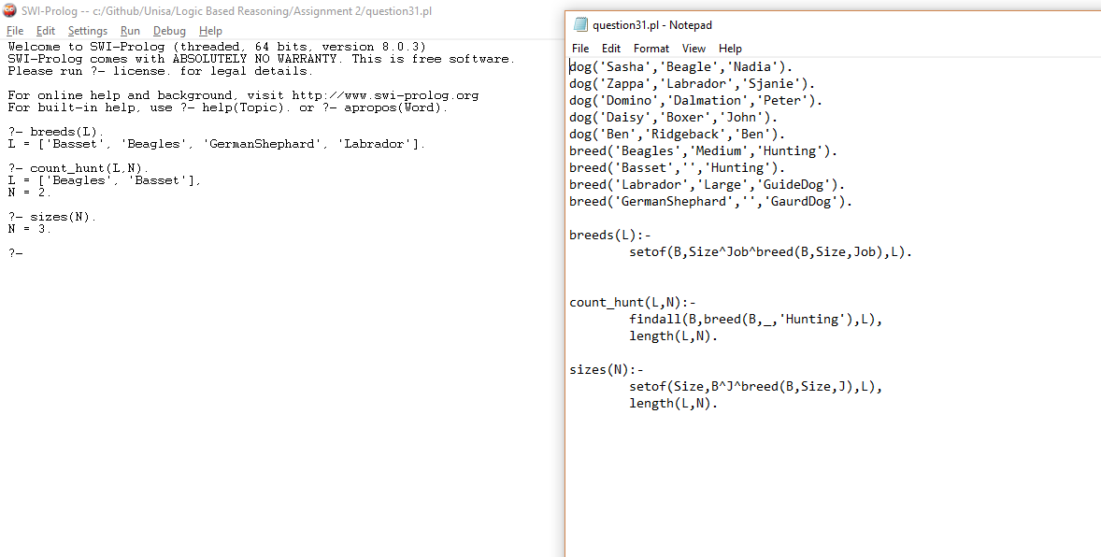

Question 3.2

Question 4a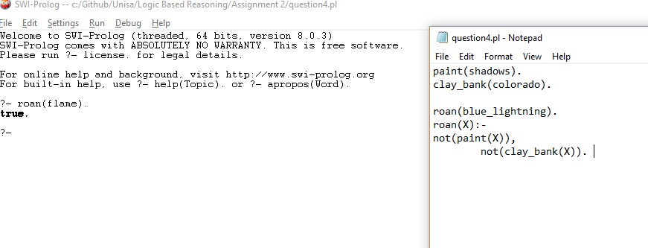

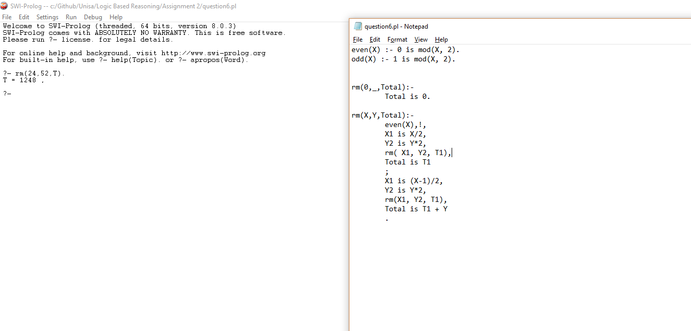

Question 4b

When the query roan(flame) is entered, Prolog first checks the statement “not paint(flame)”. Because “paint(flame)” is not established and returns false, “not paint(flame)” returns true. The same is true for “not clay_bank(flame)”. The fact “clay_bank(flame)” cannot be established and thus returns true. This means “not clay_bank(flame)” also returns true. Which leads to “roan(flame)” returning true

Question 4c

Closed world assumption

Question 5

|  |  |
| --- | --- |
| A =:= B | Matches the values of the arithmetic expressions A and B |
| A=\=B | Check is 2 arithmetic expressions are not equal |
| A==B | Check if terms are identical |
| A\==B | Check if terms are not identical |
| A=B | See if terms match |

Question 6

Question 7

